**NEW CLASSES!!!**

**Parent &Toddler Gymnastics Classes**

Every Saturday during term time 9:00-9:45 @

Ludlow college sports hall.

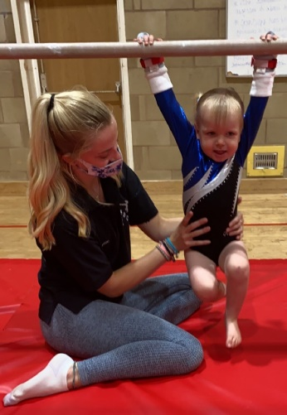

*First two sessions pay as you go, thereafter a half term block booking is required.*

*£4.90 per session.*

Join us and try out our new parent and toddler gymnastic classes, these are a great way to introduce your children to gymnastics in a fun and relaxed setting allowing them to discover through play.

Our sessions are suitable for children from 18 months to 3 years old.

Sessions are a safe introduction to soft play equipment, trampette and other modified apparatus all overseen by a qualified instructor. While children remain fully supervised and supported by their trusted adult.

These sessions offer the perfect way to socialise with like-minded parents, as well as watch your child grow and develop fundamental skills like motor control development, special awareness, confidence and much more.

To join us today, please email [ssgymnasticclub@btinternet.com](mailto:ssgymnasticclub@btinternet.com) or for more information on our classes please visit <https://www.ssgymnasticclub.co.uk/>